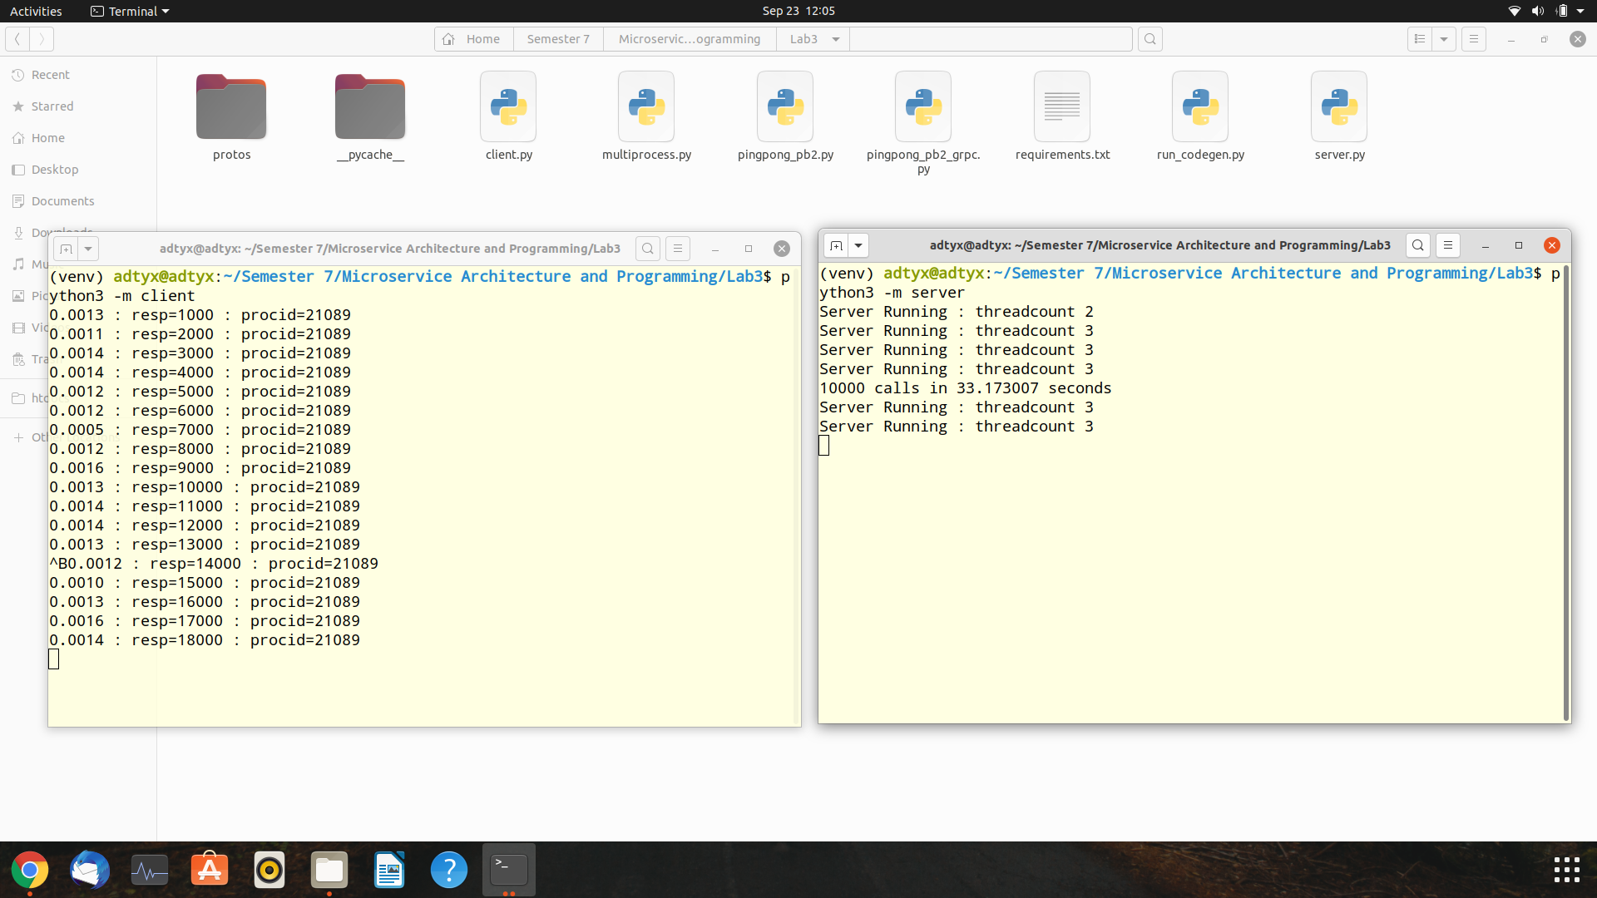

It can be seen here that I have run client file and server file in the virtual environment called venv. So, it makes 10000 calls in around 33 seconds.

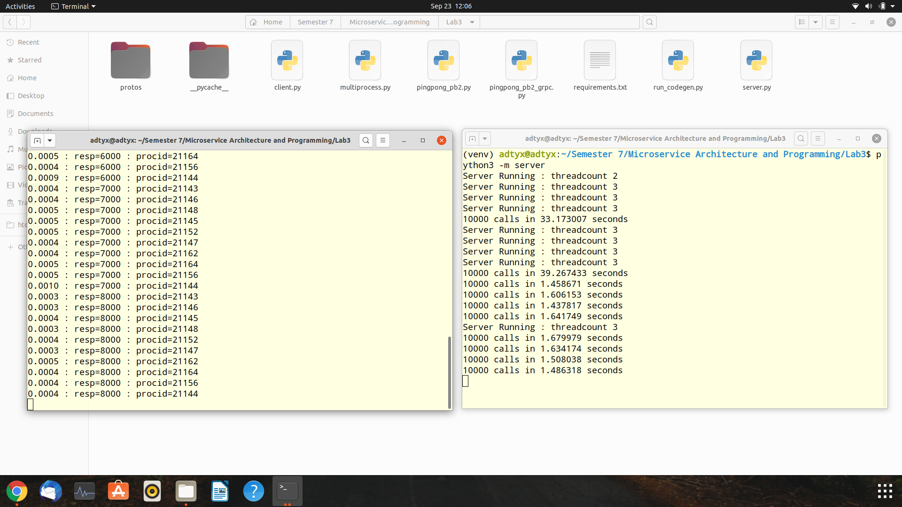

Now you can see that as soon as I run the “multiprocess.py” file through command “python3 -m multiprocess”, it can make 10000 calls through just 1.64 seconds.